**TITLE SPONSORSHIP**

**MOTOWN MONDAY NIGHT ON BOOMER RADIO!**

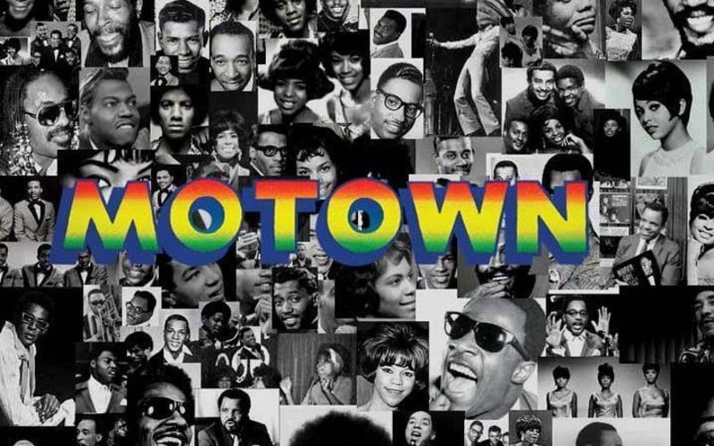

Every Monday night Boomer Radio will air a special Motown Music special with a local host and special guests! Listeners will get stories behind the music and hear the hits that made Motown and R&B great!

*Monday Nights from 6-8 on The Boomer Radio Network!*

As a title sponsor, you will receive:

* Opening and closing “title” credits
* 4 :30 commercials in each show!
* Inclusion title sponsor in 25 live/recorded promos each week!
* Bank of 30 :30 commercials each month.
* Show and commercials on the stream at myboomerradio.com!
* Sponsorship logo on myboomerradio.com

**Investment $1000 per month**

