**MOTOWN MONDAY NIGHT ON BOOMER RADIO!**

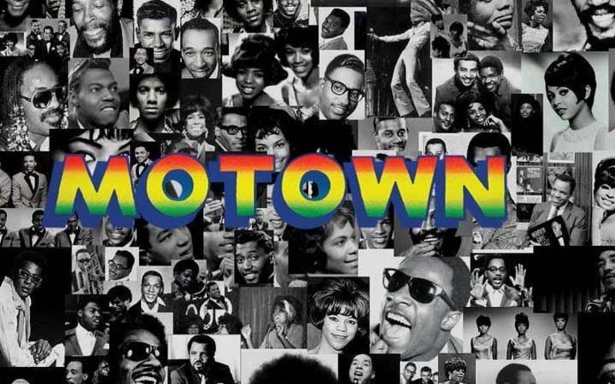

Every Monday night Boomer Radio will air a special Motown Music special with a local host and special guests! Boomer Listeners will get stories behind the music and hear the hits that made Motown great!

*Monday Nights from 6-8 on The Boomer Radio Network!*

As a sponsor, you will receive:

* 2 :30 commercials in each show along with opening and closing billboard credits!
* Inclusion in 25 live/recorded promos each week!
* Show and commercials on the stream at myboomerradio.com!
* Sponsorship logo on myboomerradio.com

**Investment $500 per month (limit 4 sponsors)**

