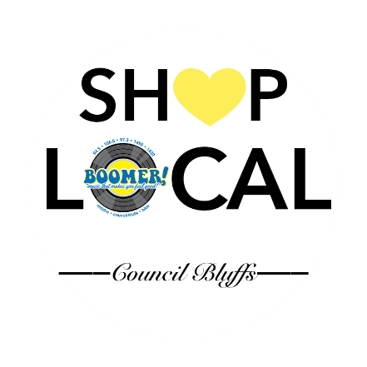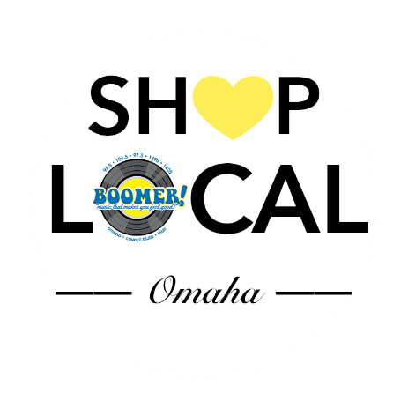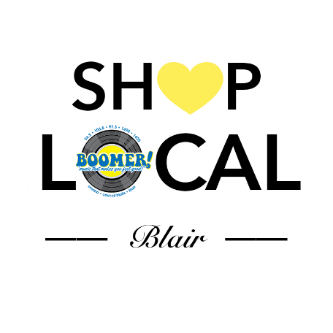

*Let’s get our local economy going again!!*

*When you* ***SHOP LOCAL****… EVERYBODY WINS!*

*BOOMER RADIO WILL HIGHLIGHT LOCAL BUSINESSES AND ENCOURAGE OUR LISTENERS TO* ***“SHOP LOCAL”*** *WITH FULLY PRODUCED :60 COMMERCIALS VOICED BY OUR AIR PERSONALITIES PROMOTING LOCAL SMALL BUSINESSES IN OUR COMMUNITY!*

Your business will receive:

* Inclusion in a minimum of 60 :60 commercials per month
* Matching schedule on the myboomerradio.com stream!
* Logo and link on myboomerradio.com website
* Inclusion in Shop Local Facebook post
* Shop Local sticker for your storefront

**Your investment: $450 per month (Boomer Network)**

**$250 per month (Blair or Council Bluffs only)**

**Accepted by: ______________________ Boomer Representative: __________________**

**Business: _________________________ Date: __________________________________**