BOOMER STICKER STOP
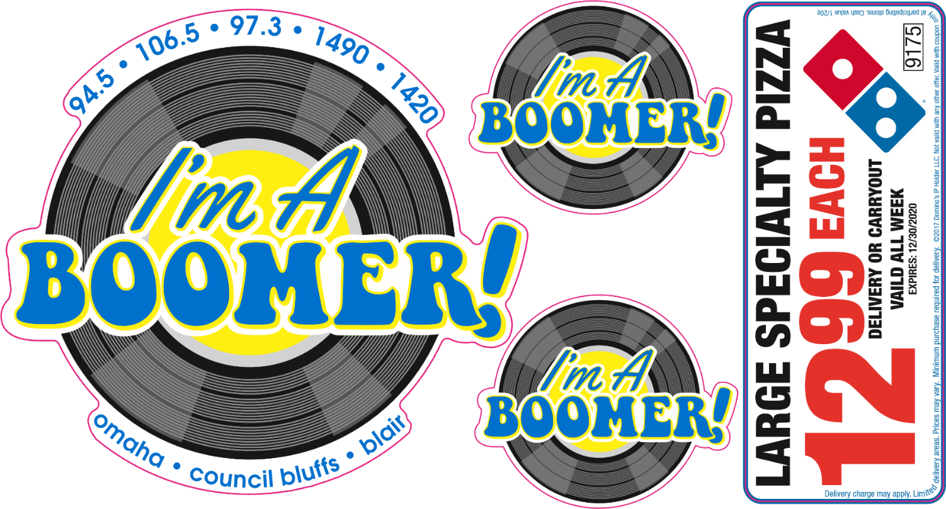

Our LIVE on-location sticker stop broadcast can boost
customer traffic to special events, grand openings, fundraisers and so much more.
We promote your business AND the sticker stop itself
with our STICKER STOP REMOTE package:
The week of the sticker stop 6a-8p
(15) :30 second spots promoting your business
(15) :30 station liners promoting the sticker stop
(1) hour on-location the day of your event

$550.00
*Limited Numbers available*

Client: _______________________________________________ Business Name: ______________________________

Date: _______________________________________________

