Walnut Media Station Overview

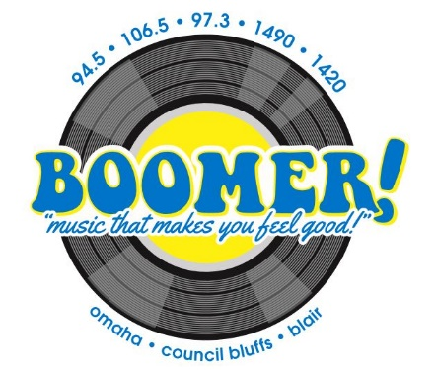
The Boomer Network is Omaha, Council Bluffs,
Blair and surrounding areas source for a blast
from the past. This “nostalgic” station plays hits
from the Boomer years – the 60s and 70s! a
listening favorite for the affluent 35+
demographic. This station features iconic Omaha
radio personalities Dave “Wingy” Wingert in
the morning, Jessica Dol middays,
and Jack Swanda in the afternoons.

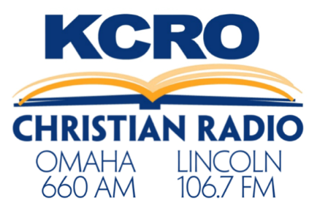
Omaha and Lincoln’s Christian talk and
teaching station, offering 24-hour
programming from well-known faith voices
and faith-based family talk shows.

Mix 105.5 is a listening favorite for the prime
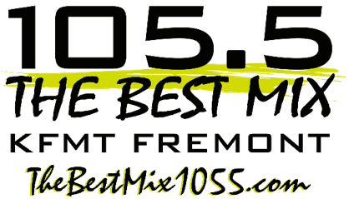
25-54 year old audience, especially women,
in Dodge County and surrounding areas –
Wahoo, Cedar Bluffs, Blair, North Bend,
Arlington, Valley, Elkhorn and
West Omaha. Mix 105.5’s music is soft
enough for office listening, but lively enough
to turn up and enjoy!

East Central Nebraska’s heritage radio station,
Big Dog has been serving Fremont and
Surrounding areas for over 75 years. This
“Country: 90’s to Now” format is targeted to
adults, 25-54, with a core demographic
of adults 30-49.

