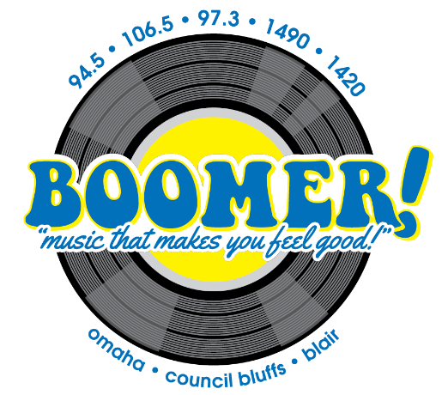

The Cubs on Boomer!

106.5 FM & 1490 AM Omaha

Sponsorship Package

As a Boomer/Cubs sponsor you will receive:
- 3 :30s in each regular season game (approx. 165 games)
- Minimum of 15 promotional mentions each week of the season
- Cubs sponsor Logo on myboomerradio.com

Optional:
- A bank of 30 :30 commercial announcements per month on the Boomer Network (6a-8p M-Sun)

Investment: $450 per month Add on Option $ 400
Billed monthly April-September for 2020 season

Yes, count me in!
Business Name: _________________ By: ______________Date_____

