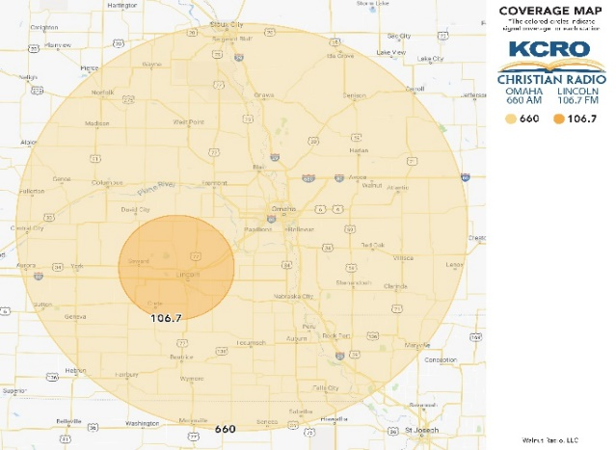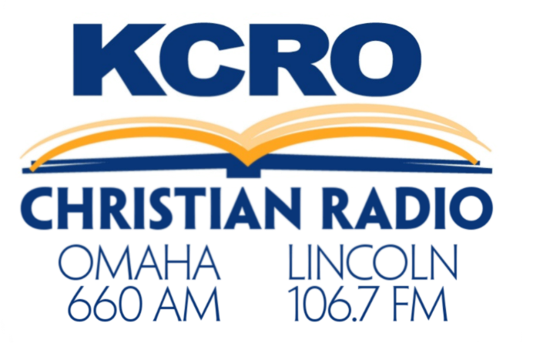

Omaha

Lincoln

KCRO is a powerful regional signal serving Eastern Nebraska and Western Iowa! We are Omaha, Lincoln and the surrounding area’s Christian talk and teaching station, offering 24-hour programming from well-known ministries and faith-based talk shows. Our listeners can learn and grow in their faith as Christians. KCRO features shows covering a variety of topics including marriage, raising children, investing, and how to live your best life, all from a Christian perspective.

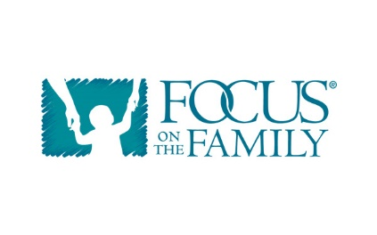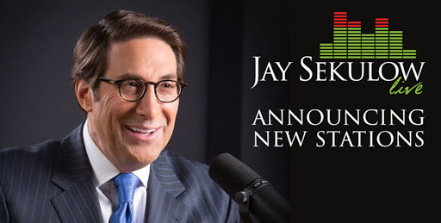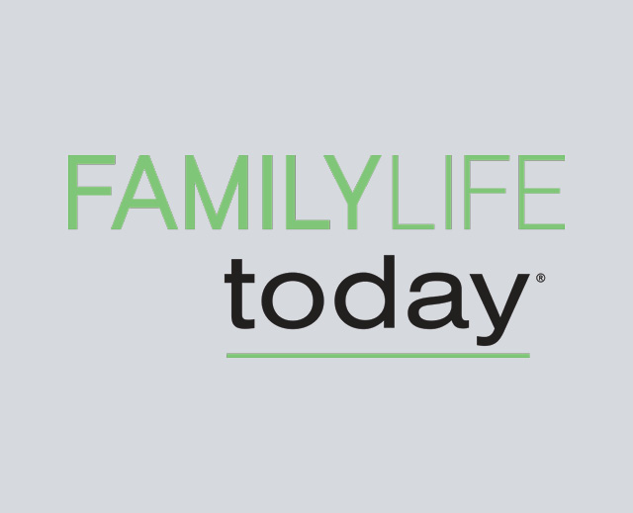

National programming includes:

-Focus on the Family - New Life Live

- Family Life Today -Joyce Meyer

-Turning Point for God -The Narrow Path

-Thru the Bible -Truth For Life

-Jay Sekulow -Gospel for Asia

We have prime dayparts available on weekdays and weekends!

For information please contact:

Station Manager Janel Reeves at 402-422-1600 or jreeves@walnutradio.com