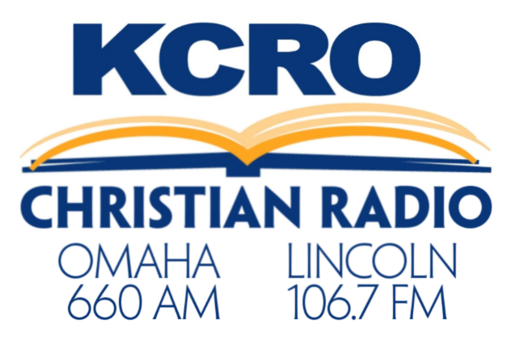

Introductory Package
KCRO is now in Lincoln and we want to make it affordable for you to advertise with us! Choose from the high frequency plans below.

Choose One:

___ 80 :30’s per month $1,200
___ 40 :30’s per month $700
___ 20 :30’s per month $450

____________________________________ ___________________
For Advertiser Date

