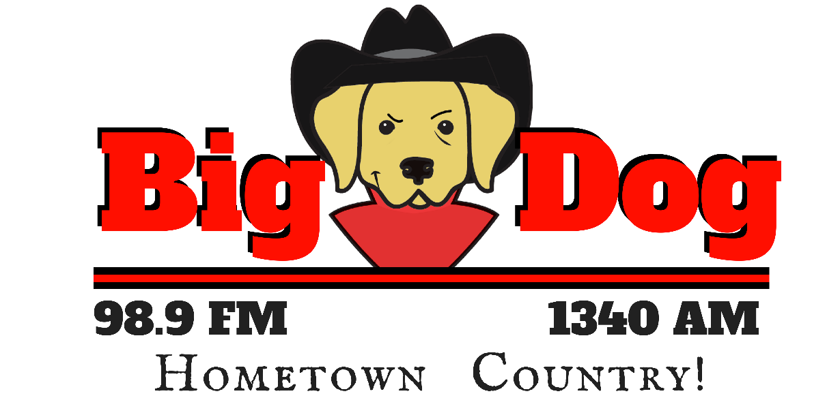
City of License: Fremont, Nebraska
Dial Position:
1340 AM / 98.9 FM
Power:
500 Watts
Website:
www.BigDogNow.com

Big Dog Country is:
- East Central Nebraska’s heritage radio station, serving Fremont and surrounding area for 75 years. The Country Essentials format is targeted to adults, 25-54, with a core demographic of adults 30-49.
- Broadcasting 24 hours, 7 days to Dodge County and the surrounding area: local news with Chris Walz, local sports with Rich Ray, and favorite country music hits all day long. Good Morning Fremont (6A-9A, weekdaily) hosted by Rich Ray & Chris Walz provides news, sports and drive time music & entertainment features to keep morning listeners engaged.
- Big Dog is the premier source of local information for both the residents of the “Hub” City of Fremont and the surrounding rural towns and areas of Dodge, Burt, Butler, Colfax, Cuming, Western Douglas, Saunders, & Washington Counties.
Core Artists

- Blake Shelton
- Brad Paisley
- George Strait
- Kenny Chesney
- Lady Antebellum
- Tim McGraw
- Alan Jackson
- Keith Urban
- Carrie Underwood
- Garth Brooks
- Martina McBride
- Rascal Flatts
- Luke Bryan
- Toby Keith

Big Dog 98.9/1340 also features the KHUB Polka Show, Sundays Noon – 3pm, CBS Sports Radio Weekends, the Husker Online Podcast Show, and Morning Fremont on Weekdays from 6-9AM with Rich Ray and Chris Walz. Big Dog 98.9/1340 carries more local sports broadcasts than any other station: Fremont High, Archbishop Bergan High, Midland University and more! Big Dog 98.9/1340 is Eastern Nebraska’s Husker Basketball and Baseball station via The Husker Sports Network.
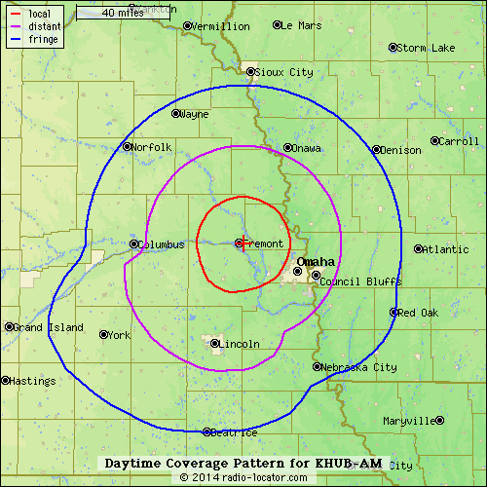
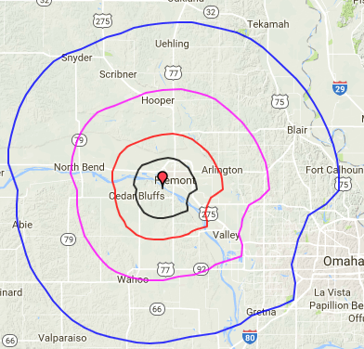
98.9 FM Coverage Pattern for KHUB

