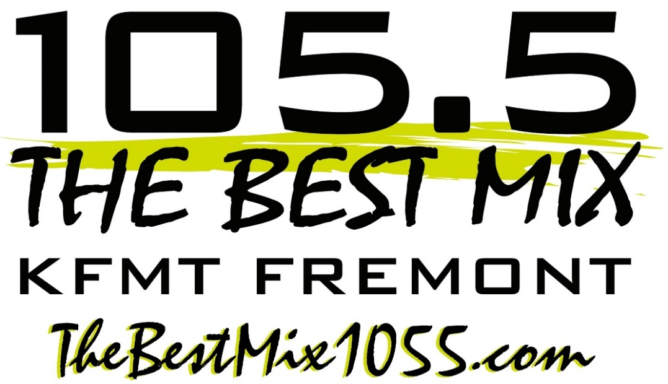
City of License: Fremont, Nebraska
Dial Position:
105.5 FM
Power:
3000 Watts
Website:
www.thebestmix1055.com

- Mix 105.5 plays a wide variety of familiar hits and is a favorite for office listening, retail store music systems, and drive time entertainment.
- The listening demographic is women 25-54, with the core listener in the key 30-45 age group.
- Broadcasting 24 hours, 7 days a week providing information & entertainment for Dodge County and the surrounding area, programing features the Morning Show hosted by Jessica Dol, local news with Chris Walz, and local sports with Rich Ray.
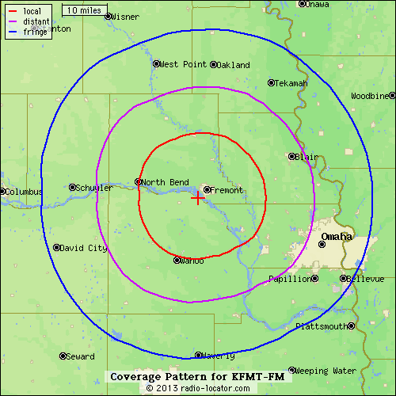
Mix 105.5 is the premier source of local information & entertainment for the residents of the City of Fremont and the surrounding rural towns and areas of Dodge, Burt, Butler, Colfax, Cuming, Western Douglas, Saunders, & Washington Counties.
Mix 105.5 music is soft enough for office listening, but lively enough to turn up and enjoy.
Mix 105.5 features favorite artists and groups like Adele, Shawn Mendes, The Police, Kelly Clarkson, Katy Perry, Madonna, Maroon 5, Billy Joel, Pink, Michael Jackson, Taylor Swift, Journey, Bruno Mars, Elton John, Lady Gaga, Colbie Caillat, Ed Sheeran, Sia, Cyndi Lauper, Imagine Dragons, Chicago, and Justin Timberlake.
Mix 105.5 is also the area’s favorite continuous Christmas Music Station from Thanksgiving week to Christmas Day, annually.
Plus Mix 105.5 is still Eastern Nebraska’s Husker Football and Husker Volleyball station, with live games brought to the airwaves by the Husker Sports Network.

