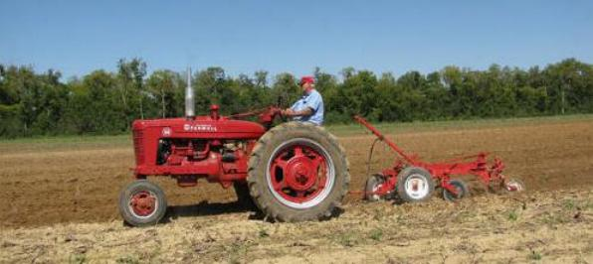

Contact: Seth Delaney 270-886-7123 Larry Larimore 270-887-3492

James Parker 270-836-6303 Charles Garnett, Jr 270-719-1020

Harvey Oglesby 847-217-2030 Bob Carrico 270-322-3011

All-Day Event

Antique tractors, plows &

teams welcome

All equipment 1975 and older

Due to Covid-19 food will not be

provided this Year. Bring a bag

lunch and make a day of it.

**Hal Fennell Memorial**

**Antique Tractor Plow Day**

**Saturday, October 2, 2021**

(Rain Date: Oct. 9, 2021)

Hosted by Garnett Farms

4255 Hwy 1027 (Long Pond Road) Hopkinsville, KY

Sponsored by Western KY Antique Power Association

Start Time: 9:30 am

For information contact: Seth Delaney (270) 886-7123 Bob Carrico (270)322-3011

Bob Brown (270) 322-8778 Charles Garnett, Jr. (270-719-1020)

Directions:

From Hopkinsville 68/80 Bypass take Ky 109 (Bradshaw Road) go 5.4 miles to Hwy 1027

(Long Pond Road), turn left and go 0.7 miles to site on right.

From US41A Ft. Campbell Blvd (9 mile marker) take Hwy 1027 East (Long Pond Road) go 4.3 miles to site on right.

From Pembroke, KY take Hwy 115 South/1027 West go 1.3 miles to Hwy 1027 West (Long Pond Road). Go 2.3 miles to site on left.

*[Type a quote from the document or the summary of an interesting point. You can position the text box anywhere in the document. Use the Drawing Tools tab to change the formatting of the pull quote text box.]*