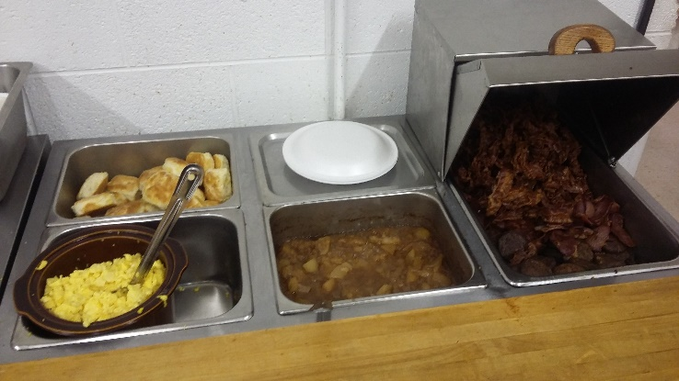

**FAIRYSTONE VOLUNTEER FIRE DEPARTMENT**

**COUNTRY BREAKFAST**

**May 18, 2024**

**6:30 a.m. until 10:00 a.m.**

**Dine in Price:**

**Adult Plate $10.00 Child Plate $5.00**

**Take out Price:**

**All to go plates are $10.00 each.**

**Call in orders (276) 930-2113**

**Sponsored by:**

**Fairystone Volunteer Fire Department & Ladies Auxiliary**

**6687 Fairystone Park Highway – Route 57 West**

**Stuart, Virginia 24171**