New Release
January 8, 2019
For Immediate Release

David Dahl to run for Washington City Councilman At-Large
David Dahl is running for a seat on the Washington City Council as a councilman-at-large, in the May 2019 Primary.
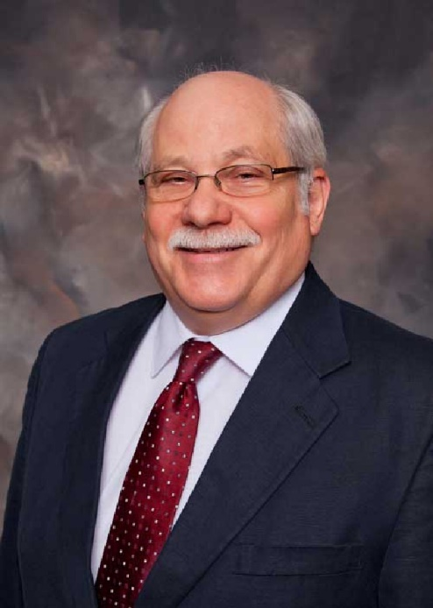
“I want to continue moving Washington forward,” said Dahl. “For nearly forty years I designed water and sewer systems throughout southern Indiana. In my opinion, Washington is blessed with talented and conscientious employees. Workers who will jump into a muddy trench to repair a leak, or unclog a sewer, or brave the elements to keep the lights on and collect our trash. We sleep well because we have dedicated police officers and firefighters keeping watch. We owe it to our workers to provide them with the proper equipment, tools and wherewithal to safely and efficiently complete their mission.”
Dahl, a Republican, was appointed to the council in 2016, to fill a vacancy. Dahl retired from Midwestern Engineers, Inc. in 2015 having served 20 years as President/CEO. A Registered Professional Engineer, Dahl was Project Engineer for numerous civil engineering projects including water treatment plants for the City of Washington and the Patoka Lake Regional Water District. For Patoka, he designed their Ultraviolet/Advanced Oxidation Process for taste and odor removal. Dahl also developed sewage treatment facilities for the Cities of Washington and Boonville and the Towns of Corydon and Shelburn. He was responsible for structural and street improvement projects, including several projects at Holiday World, Inc., for queuing stations, ride pumps, wave and splash pools. He still consults with Holiday World.
He was an Adjunct Professor of Engineering in the College of Science, Engineering, & Mathematics at Vincennes University, and a past president of American Council of Engineering Companies of Indiana. In 2005 Dahl received ACEC Indiana’s Consulting Engineer of the Year Award. He has been a member of the State of Indiana Regulated Amusement Device Safety Board, since its creation in 1996.
A part-time author, Dahl recently completed a detailed history of the Patoka Lake Regional Water and Sewer District. He and his wife Elain have two grown children that live in Washington, and they feel blessed to have their grandchildren near.
“Each morning I exercise by walking the streets of Washington. I am proud of what I see. Everywhere homes are being fixed up and yards landscaped. Washington is truly a good place to live, and I want to keep us prospering.”
<end>

