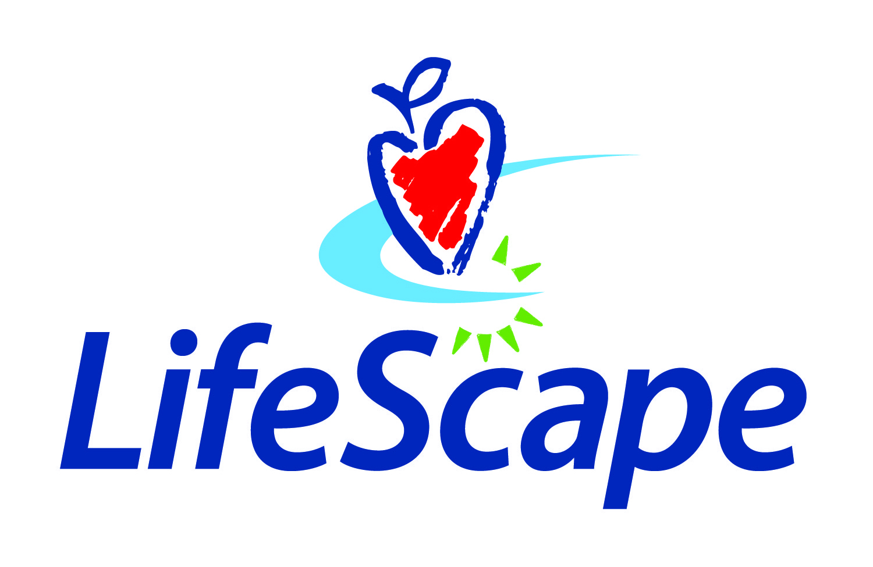
Organization name: LifeScape
Date: December 10, 2019
Time: 10:00 a.m. – 9:00 p.m.
Location: Blaze Pizza – Rapid City
1325 Eglin St.

