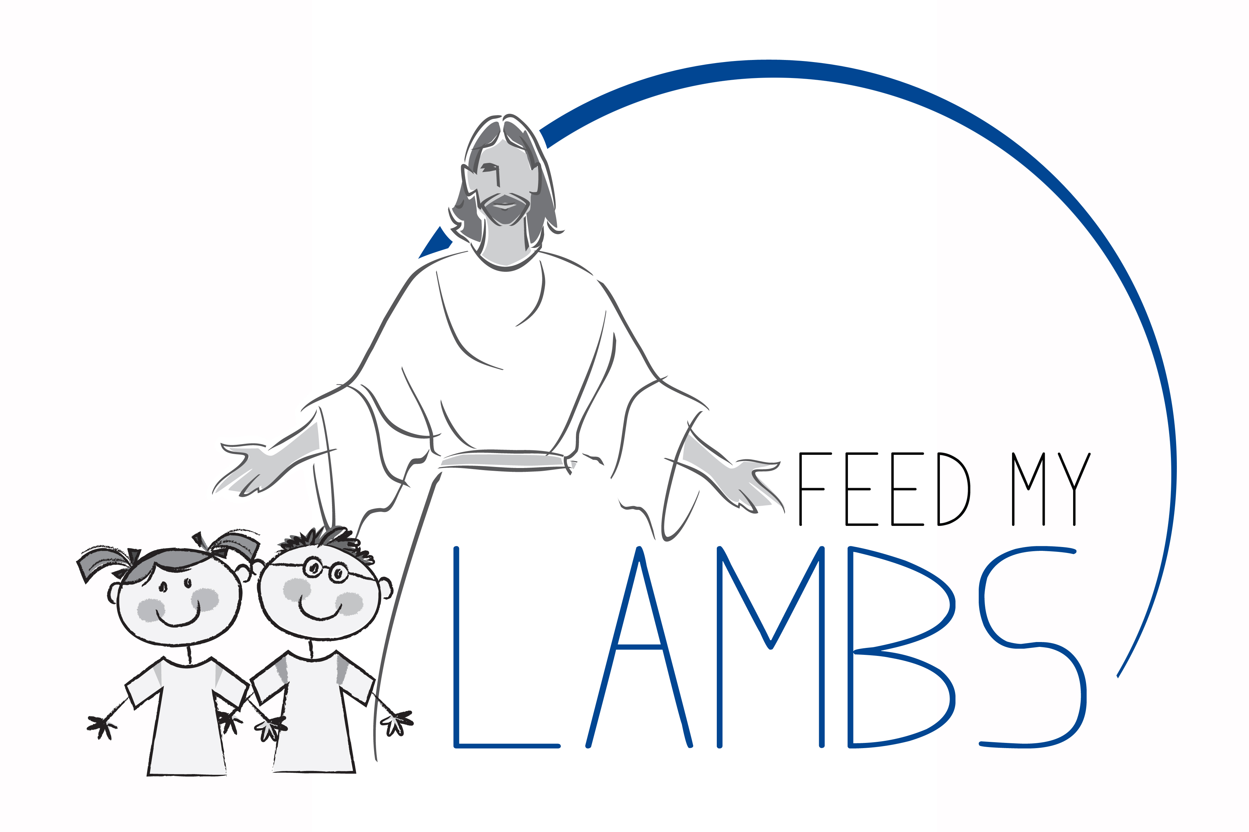
10th Annual – 5k Walk/Run/Bike Ride
REGISTRATION TIME IS 7:00 A.M. TO 7:45 A.M.
STARTING TIME IS 8:00 A.M. at the Abingdon Christian Church on Saturday, September 9, 2023

A fundraiser for the “Feed My Lambs” project to help feed families in need during the summer and on weekends. Area Churches are providing food baskets and snack packs to children in the community of Abingdon.

YOU MAY REGISTER THE DAY OF THE RACE. FREE SHIRT WITH EACH REGISTRATION UNTIL SHIRTS RUN OUT. COME EARLY IF YOU WANT A SHIRT.
(ONE FORM PER PARTICIPANT)

(Check One)
Race Participation:
Entry Fee $20 [] Walk [] Run []Bike Ride

Please Print
Name

Address

State Zip Phone # Email

Age (Please check) [] Male [] Female

Amount Enclosed: (checks payable to “Feed My Lambs” project)

Waiver: Upon accepting my application and in consideration of allowing me to enter this event, which I agree is at my own risk and entirely of my own free will I hereby for myself and on behalf of my heirs, executors, administrators, and assigns, waiver, release, and discharge race organizers, race volunteers, sponsors, and promoters from any responsibility or liability whatsoever for any losses, injury, or other damage sustained in any activities during or surrounding the event. I also give permission for the free use of my name and picture in any broadcast, telecast, or print media account of this event or subsequent similar future events.

Signature Date

Send registration form(s) with payment to: Abingdon Christian Church, 409 S. Main St., Abingdon, IL. 61410, or drop off form(s) with payment at Tompkins State Bank or Raritan State Bank in Abingdon, Il.. Registration fees are non-refundable

