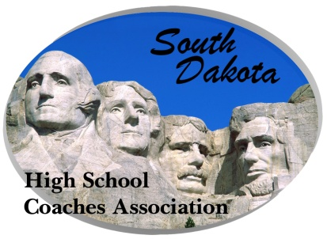
South Dakota High School Coaches’ Association

801 W Eagle Ridge Street

Sioux Falls, SD 57108
(SDHSCA@k12.sd.us)
Federal Non-profit ID#: 23-7297479

FOR IMMEDIATE RELEASE:

Sioux Falls, SD – The South Dakota High School Coaches Association announces the Coach of the Year Awards for the Spring of 2019 (Other nominees listed below each winner):

Boys’ Golf – Joey Liesinger, Madison
Frank Cutler, Platte-Geddes; Jeff Halseth, Jeff Halseth, Sioux Falls Lincoln; Jim Person, Sisseton; Nick Rotella, Rapid City Stevens
Girls’ Golf – Billie Jo Indahl, Burke
Tom Jansa, Sioux Falls O’Gorman
Tennis – Mike Zerr, Brandon Valley
Tom Krueger, Sioux Falls Lincoln; Jason Olson, Rapid City Stevens; Steve Steele, Pierre; John Vogel, Aberdeen Central; Ryan Zink, Watertown
Boys’ Track & Field – Bill Hansen, Viborg-Hurley
Scott Benson, St. Thomas More; Jim Jarovski, Sioux Falls Lincoln; Karol Patterson, Wall
Girls’ Track & Field – Rachelle DeBeer, Deubrook Area
Jim Jarovski, Sioux Falls Lincoln; Cliff Johnson, Andes Central; Byron Pudwill, Bon Homme

Last year’s winners:
Boys’ Golf – Frank Cutler, Platte-Geddes
Girls’ Golf – Clark Gusso, Belle Fourche
Tennis – Kerry Dilley, Pierre
Boys’ Track & Field – Rory Hermsen, Freeman Public
Girls’ Track & Field –Bill Abell, Belle Fourche
These coaches will be recognized at the annual awards banquet to be held at the Highland Conference Center in Mitchell on Sunday, July 7, 20189 at 1:00 PM.

Jim Dorman, Executive Director
SDHSCA

