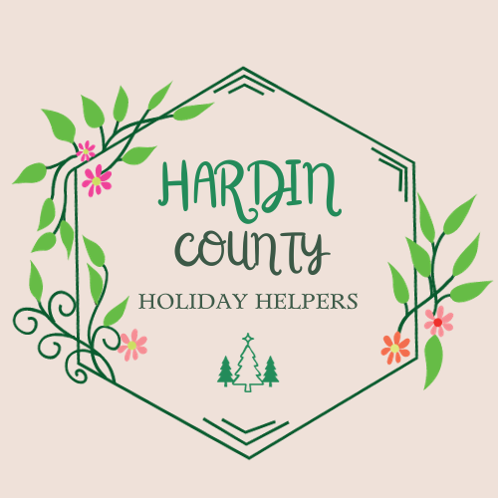

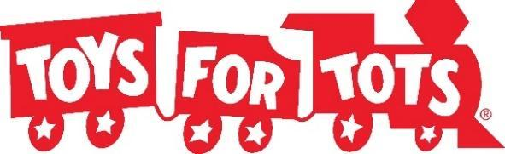


FOR IMMEDIATE RELEASE
January 6, 2025
Contact: Rocky Reents, (641) 220-2315
rockyreents@gmail.com

FOUR HUNDRED SIXTY SIX CHILDREN SERVED THROUGH HARDIN COUNTY TOYS FOR TOTS

Hardin County, Iowa – Christmas is always expensive, but there is even more stress each year with the rising costs of living. The expectations of the season plus the expense of gifts and food can make Christmas an extremely stressful time for families. A realistic Christmas budget depends on your financial situation but typically ranges between 1% and 2% of your annual income. On average parents spend about $460 per child each Christmas.
On Saturday, December 14th the Hardin County Holiday Helpers in partnership with Bethany Lutheran Church, the Iowa Falls Rotary, and the Marine Corps Toys for Tots hosted our annual Christmas Event for Hardin County Families who are experiencing financial hardship. This event provided something for the whole family including a free breakfast, a Kids Christmas Zone full of crafts, cookie decorating, Santa visits, a room for children to pick out a gift for their parents, and the toy room where parents were able to pick out toys for their children. In total, approximately 466 children from 161 Hardin County families were served through the event on December 14th. Volunteers from Bethany Lutheran Church, Greenbelt Home Care, Iowa Falls Rotary, Iowa River Valley Early Childhood Area, and staff from Ellsworth Community College helped parents pick out toys for their children, assisted children with cookie decorating and crafts, and served breakfast to the families that attended.
Toys for Tots donation boxes were placed in businesses around Hardin County where community members donated new toys to, toys were received directly from the Marine Toys for Tots campaign, as well as many monetary donations that came in to assist with providing toys for Hardin County children.
Thank you to the following entities for collecting toys for our event: Happenings Bar, Theisen’s, WalMart, HyVee in Iowa Falls and Eldora, Dollar General in Iowa Falls and Eldora, Hansen Family Hospital, Radcliffe Public Library, Hubbard Public Library, Fareway in Iowa Falls, Greenbelt Bank & Trust in Eldora and Iowa Falls, Hardin County Savings Bank, Iowa Falls State Bank, Norby’s, GNB Bank, Bethany Lutheran Church, Quakerdale Farms, and Greenbelt Home Care.
Thank you to all who made this event possible from the Hardin County Holiday Helpers!
Robin Sampson, Rachel Loyd, Whitney Driver, Kala Eller, & Rocky Reents

###
