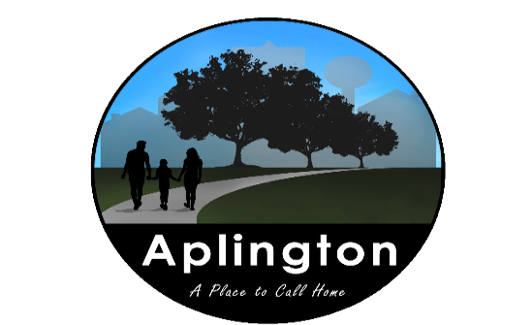

NOTICE OF PUBLIC MEETING AGENDA APLINGTON CITY COUNCIL
Wednesday, May 13, 2026
6:00 p.m. Aplington City Hall
This will be an open meeting.
Discussion and possible action on all items listed below:
Old Business
- Call meeting to order
- Public Comments
- Consent Agenda
    - Agenda
    - Minutes April 8, 2026 and April 27, 2026
    - Financial Report ending April 2026
    - Payment approval of Claims
- Public Works Department
  - Sealed Street Bids
  - Summer Help
  - Clean up Day
  - MSA 2026 Diffuser Analysis
  - Pool – Remove
  - Building Permit – First Reformed Church
- Department reports
  - Police – part-time help
  - Fire
  - Library
  - Ambulance – BC EMS Mutual Aid Agreement
  - Pool
- ARC – Lease Agreement
- Casey’s – Tobacco License
- Travis Fleshner -School Update/28E Agreement - Librarian
- Ralph Mohwinkle – Water in yard
NEW BUSINESS
- Any other business brought before the Council
- Adjourn
____________________________________
Michelle Thede, City Clerk

