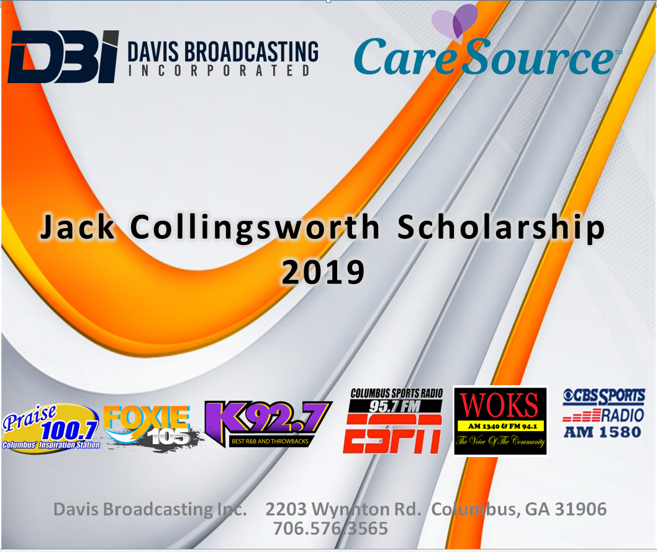

Dear Future Leader Applicant:

Congratulations on taking that next step on this journey of life. Davis Broadcasting has been a longtime supporter of higher education in the Tri-City community. Our previous Broadcast Engineer, Jack Collingsworth, had a heart for seeing students flourish by practicing and perfecting their talents in all areas of radio broadcasting. He knew the value of a good education, and certainly understood that finances play a key role in being able to pursue secondary education. Davis Broadcasting Inc. established the Jack Collingsworth Scholarship in 1988 to honor his legacy of hard work and love for his craft. Davis Broadcasting Inc. and our 2019 partner Care Source Georgia will continue in this tradition by offering a one thousand dollar ($1,000) scholarship to a deserving 2019 graduate. Our purpose is to help alleviate some of the financial responsibility thus allowing students to focus on academic pursuits.

We hope to be able to serve you in your upcoming educational endeavors by providing a scholarship for your upcoming school year. Please complete your application in its entirety and satisfy all of the requirements.
This year’s 2019 scholarship is presented by Davis Broadcasting Inc. and Care Source Georgia on June 15th, 2019. The Scholarship amount is $1,000.00. Applicants must be a 2019 graduate of a high school in the Muscogee, Russell or Chattahoochee County headed to an accredited College, University, or Technical School.

Sincerely,
Geniece R. Granville

Geniece R. Granville
Vice President
Davis Broadcasting, Inc. of Columbus

SCHOLARSHIP REQUIREMENTS
Each of the following items must accompany all applications in order to qualify for a scholarship:
(1) Letter of acceptance from an accredited college or university or technical School
(2) High School transcript from a local high school. Russell, Muscogee, or Chattahoochee County School
(3) Minimum 3.0 Unweighted GPA (4.0 scale)
(4) Two letters of recommendation (one academic/professional and one personal)
(5) 500 word essay on topic: PLEASE ANSWER TWO QUESTIONS BELOW.
Essay Question:1) How will your pursuit of higher education contribute to your immediate or long range career plans? 2) How will your pursuit of higher education impact positively on the society you live in? 3) If you had the authority to change your school in a positive way, what specific changes would you make?

Student Name: Date:
Address Phone:
High School Name and Graduation Date:
Name & Address of College You Will Attend:
Desired Major/ Minor:
Indicate AP or Honors Courses:
Extracurricular, Community and Church Activities:
Hobbies and Special Skills:
Email Address (Parent/Guardian):
Email Address (Student):
Parent/Guardian Name Phone:
Present Employer Phone (if applicable):
List Names and of Two References (1. Professional/Academic 2. Personal)
1.)_________________________________________________________________________________________Phone Number_______________
2.)_________________________________________________________________________________________ Phone Number_______________
SCHOLARSHIP APPLICATION

STUDENT AGREEMENT
I hereby certify that:
I am a graduating senior that will be attending a qualified secondary institution.
I will use the proceeds of this scholarship for the payment of tuition required,
fees, books, room & board or similar living expenses. I understand that the
proceeds from this scholarship will be remitted to me with the above understanding.
I understand that, if selected for a scholarship award, I am expected
to be present on Saturday, June 15, 2019 for the award presentation.
I understand that the $1,000 scholarship is not renewable.

Signature of Applicant: _________________________________________ Date: ________________________

PARENT/GUARDIAN STATEMENT
This is to certify that:
We/I know about and approve of this application for the Davis Broadcasting Jack Collingsworth Scholarship.
We/I concur that the information provided on this application is accurate.
We/I concur with the statements made in the student agreement above.

Signature of Applicant: _________________________________________ Date: ________________________
Signature of Parent/Guardian: ___________________________________ Date: ________________________

Submit applications via mail or email to:
Davis Broadcasting Jack Collingsworth Scholarship
P.O. Box 1998
Columbus, GA 31902
Scholarship@dbicolumbus.com

APPLICATION DEADLINE: May 24, 2019
* Scholarship recipients must be present on Saturday; June 15, 2019 to receive Scholarship.

