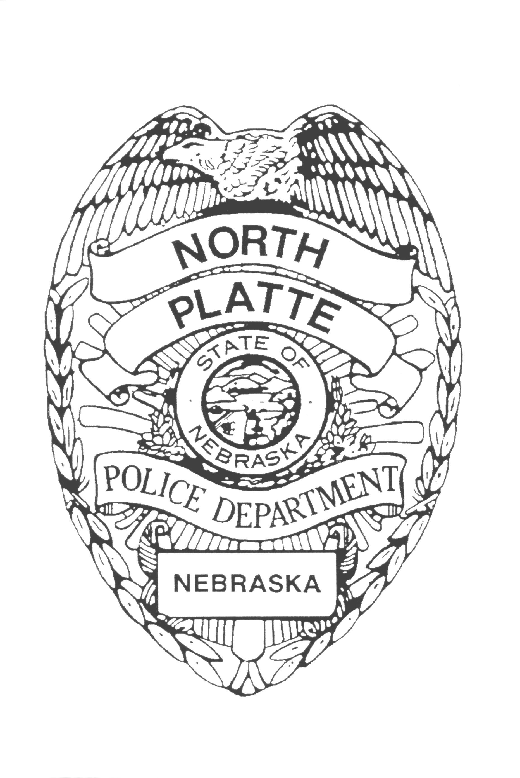
N.P.P.D. Press Release
____________________________________________________________________________________

November 21, 2022

At 12:11 PM, on Sunday, November 20, 2022 police officers were dispatched to the area of Buffalo Bill Ave and Anna Ave to conduct a welfare check on a male subject who was acting erratic. Upon arrival, they located the subject who was brandishing a golf club. The man retreated into a nearby residence and fired projectiles at the responding officers, cracking a windshield on one of the patrol cars. The man would not respond to the officers repeated request to come out of the house. He barricaded himself inside, threatened to kill the responding officers, caused extensive damage to the home and threw items out broken windows at the officers. The scene was secured and additional assistance was requested from the Lincoln County Sheriff’s Office and the Nebraska State Patrol. Attempts to create a meaningful dialog with the man were unsuccessful. Chemical agents were deployed during the incident and officers were able to talk the man into surrendering around 10:30 PM. The 33-year-old man was taken into Emergency Protective Custody and transported to Great Plains Health.

The incident was complicated by someone trespassing using an unmanned aircraft in violation of Nebraska State Statute 28-521(2). That matter will be investigated independently, and anyone having information concerning the unmanned aircraft is encouraged to contact the police department.

In addition, a local media outlet chose to live stream the incident. Such conduct provides the suspect with real-time intelligence to counter police tactics. Participating in this type of activity makes the situation more dangerous for the responding officers. For the protection of law enforcement and the general public, we ask that people stay away from the scene and wait until law enforcement has time to resolve the situation and release factual information.

Steve Reeves
Chief of Police

