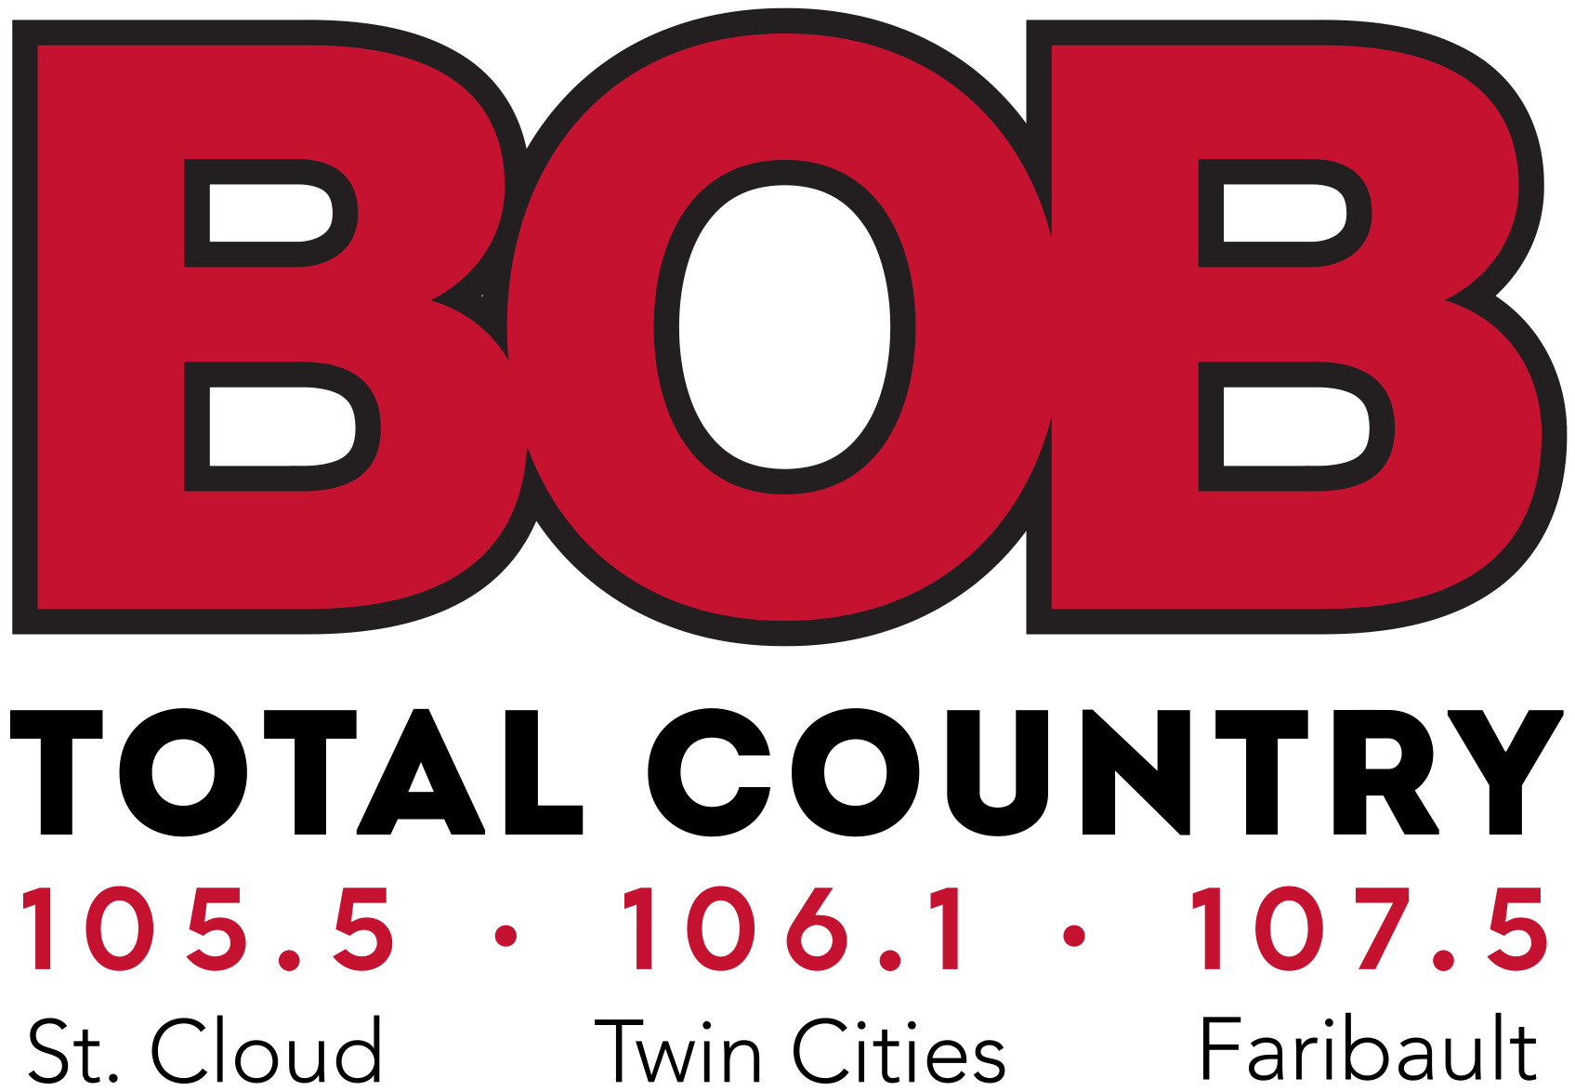

Total Country BOB FM
1443 Armstrong Blvd. NW
Ramsey, MN 55303
mybobcountry.com

PRESS RELEASE

Total Country BOB FM employees to apply for open positions with the Minnesota Vikings

RAMSEY, Minn. (January 12, 2022) – Two on-air personalities of Total Country BOB FM to publicly apply for the General Manager and Head Coach position for the Minnesota Vikings.

The Minnesota Vikings is searching for a new General Manager and Head Coach for their program. The process of hiring new managers and coaches is all internal, but that doesn’t stop certain people from wanting to shoot their shot.
Qualifications for our General Manager recommendation:
- 20+ years’ experience as Senior Management at a multi-million-dollar entity in the Metro area.
- 20+ years’ experience managing National and International outreach and public relations.
- 25+ years’ experience negotiation millions of dollars’ worth of broadcasting contracts
- 30+ years’ experience acquiring and developing legacy talent.
- 35+ years’ experience of coaching, developing, and growing the value of brands throughout the state of Minnesota.
- 50+ years’ experience of talent evaluation of all levels of football.
- Looks good in purple.

Qualifications for our Head Coach recommendation:
- Managed 5 teams of All-Star players
- Lead all 5 teams to championship games, winning with 4
- 5 championship appearances in last 10 years with 3 wins
- Quoted by multiple former players as a player’s coach
- A player-relatable, youthful energy that could blossom into a legacy tenure.
- Has a career win percentage of 58%
- Has a fiery vocabulary when addressing disagreements with officials.

