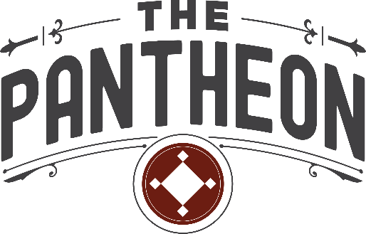

The Pantheon has always been more than a building. It represents what is possible when a community chooses to invest in its own people and ideas. Over these past six years, it has been inspiring to watch that vision come alive, to see this place fill with energy, collaboration, and hope. As I prepare to pass the torch, I do so with deep gratitude and confidence in what comes next.
When we began in 2019, The Pantheon was just an idea, a belief that a rural community could create a place where innovation, creativity, and entrepreneurship could thrive. Today, that belief is a living reality. The Pantheon has become exactly what it was meant to be: a place where thinkers and doers come together to tackle challenges, grow ideas, and create opportunity.
I am most proud of the team we have built. Their dedication, creativity, and care have turned this historic theater into a place filled with purpose. Every coworker, partner, and entrepreneur who has walked through our doors has helped prove that innovation and beauty can flourish anywhere, especially here at home.
It is good to dream big, but true progress happens when we create the systems that make the work possible. Since the 1990s, Knox County has lost ten percent of its population and more than a quarter of its small businesses. Out of that reality came The Pantheon, an intentional system for developing new business and innovation. We recognized that rural Indiana needed another arrow in its economic development quiver. We had to start investing in the ideas of our own people.
The State of Indiana has noticed. The Pantheon is now seen as a working prototype for how to build and sustain a rural innovation and entrepreneurial hub. Once again, Indiana’s First City is a first. We did this by aiming higher and doing more than we thought possible, by believing that rural places can be centers of creativity, technology, and opportunity.
Place matters. Beauty matters. Beautiful places lift our hearts up. I once heard it said that unhappy people do not build beautiful things. I am proud that we saved one of Vincennes’ most iconic buildings and gave it new life, a place where people come with ideas, find encouragement, and leave ready to build something of their own.
To our community leaders, donors, and members, thank you. Thank you for rising above the noise, for doing the hard work, and for choosing to build instead of tear down. No garden grows without getting our hands dirty, and love always requires sacrifice. This work has been all of that and more, challenging, meaningful, and deeply rewarding. Through it all, I remain grateful for the opportunity and for the growth.
I have always loved the story of a young Red Skelton selling newspapers outside The Pantheon in the 1920s. He had never been inside the theater. One evening, a well-dressed man stopped to buy a paper and asked Red if he would be attending the show that night. Red said no, he could not afford a ticket. The man smiled and said, “Tell you what, I will buy the rest of your papers and a ticket for you. Run home and ask your mother if you can go. It will be waiting for you.” Red ran home, got permission, and came back to find his ticket ready at the box office.
He climbed up to the balcony for his first-ever show. When the curtain rose, the man who had bought his ticket, Ed Wynn, stepped onto the stage as the star performer. Wynn would later become Red’s mentor and friend. Red said that evening changed the course of his life, sparking his dream to make people laugh for a living.
His dream began at The Pantheon. And dreams still get their legs here. People come with ideas and leave with courage and support. They find mentors, partners, and friends who remind them, just as Ed reminded Red, that sometimes all it takes is a simple act of kindness to help a dream take flight.
It has been an honor to serve this mission and this community. I will always believe in what The Pantheon stands for, and I will always be one of its biggest supporters.
Nichole Like
Vincennes, Indiana
November 12, 2025

