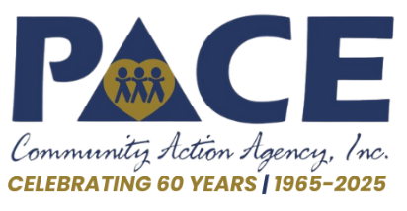


December 11, 2025 For Immediate Release
Contact: Tai Blythe 812-882-7927
Email: tblythe@pacecaa.org

Community Support Helps Keep Pace Head Start Open During Government Shutdown

Pace Community Action Agency’s Head Start program is extending its deepest appreciation to the many individuals, businesses, and organizations who rallied behind the agency during the recent federal government shutdown. While Head Start programs across the nation faced difficult closures and service interruptions, Pace Head Start was able to continue serving children and families thanks to the remarkable generosity of the local community.

“From all of us at Pace Head Start — thank you. And even that doesn’t seem like enough,” said Tai Blythe, Pace CEO, who noted that the agency felt truly uplifted during the very uncertain time. “In a moment of uncertainty, our community partners stepped forward without hesitation. Because of our generous donors, caring volunteers, supportive parents, dedicated staff and board members, and everyone who contributed, our children felt safe, supported, and surrounded with love.”

Throughout the shutdown, community members delivered supplies, made financial contributions, volunteered their time, and helped spread the word about the agency’s needs. This outpouring of support ensured that classrooms remained stable and welcoming for children, despite the national disruption.

Pace Head Start gives special recognition to several key supporters, including the North Knox School Corporation, Greene County Foundation, American Legion Post 121, United Way of Daviess County, the Vincennes University Foundation, the McCormick Family Foundation, VFW Post 1157, and Hoosier Uplands, a fellow Community Action Agency. Their contributions, along with donations from countless other organizations, businesses, and individuals, played an essential role in sustaining the program during the shutdown.

It is important to note that even once the shutdown was over, Pace Head Start did not immediately receive funding. Blythe said, “It was December before we received our Head Start grant and were able to access our funding. As an agency, we are still operating without access to our Energy Assistance funding. The impacts of the shutdown are still very real.”

Pace Community Action Agency expresses its heartfelt thanks and reaffirms its commitment to strengthening families and empowering communities.

To learn more about Pace’s Head Start program, visit www.pacecaa.org/head-start.

###

