**ILLINOIS DEPARTMENT OF NATURAL RESOURCES**

**PROJECT ORIENTATION FORM**

**Date: October 5, 2022**

**DNR FILE # 1-23-010**

**CDB # 102-249-073**

**LOCATION: Starved Rock State Park**

**2678 E 875th Road**

**Oglesby, Il 61348**

**PROJECT TITLE: Trail System and Other Improvements**

**I. BACKGROUND**

Starved Rock State Park is located along the Illinois River one mile south of Utica in LaSalle County, Illinois. The 2,630-acre park is characterized by its steep sandstone canyons formed by glacial meltwater and is rich in early American history. The property was purchased and developed into a state park in 1911 and in the 1930's the Civilian Conservation Corps built the lodge,16 cabins and recreation facilities on the bluffs overlooking the Illinois River.

**II. PROJECT DESCRIPTION**

The pedestrian trail system at Starved Rock State Park contains numerous wooden bridges, stairways, boardwalks and retaining walls which have deteriorated and need to be replaced. The iron filtration system for the potable water system is over 20 years old and needs repairs to function properly. The existing wooden vault toilets are not adequate to serve the public and need to be replaced. The campground currently does not have any campsites with 50-amp service which is not sufficient for modern Recreational Vehicles.

**III. RECOMMENDED SOLUTION**

The following park improvement projects are listed in priority order and are located throughout the park as shown. The consultant is to investigate and prepare a preliminary design and cost estimate for each project which will be reviewed at the PAPD submittal. Final project selection for construction will be determined as funds are available for these repairs.

1. **Trail Improvements to the Tonti Canyon and LaSalle Canyon Bridge & Trail System**.

This work will renovate or replace 11 timber bridges, 2 stairways and multiple wooden boardwalks and retaining walls in Both Tonti Canyon and LaSalle Canyon. This project includes replacing LaSalle Canyon bridges 1 - 9, Tonti Canyon Bridges 1 and 2, Tonti Canyon steps 1 and 2, and the Stone River Trail /Lasalle Canyon bridge (#12).

IDNR will consider the possible removal of one or more bridges, including trail closure, to reduce the project cost and save disturbance of natural areas as part of this item.

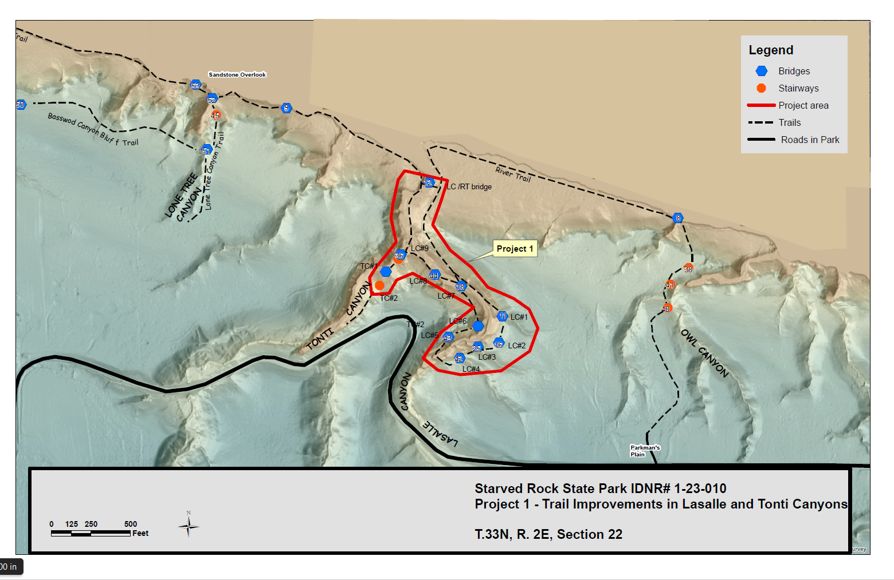

2: **Trail Improvements to Lower French Canyon River Trail bridge /Jacob's ladder**

This work will survey the lower French Canyon trail (on the west side of the ravine) from Stairway 1 to Stairway 34. The project will include the removal and replacement of bridge #34 and expanding the boardwalk from bridge #34 to existing stairway #35

The project also includes stabilizing and repairing the trail called Jacob’s ladder (heading east) which is too narrow. Additional stairways are needed to connect to the next stairway system

In addition, the trail has failed in an area on the upper end of the west side trail where a tree has uprooted the trail. This area needs to be re-routed east or an elevated platform needs to be constructed where the tree has uprooted.

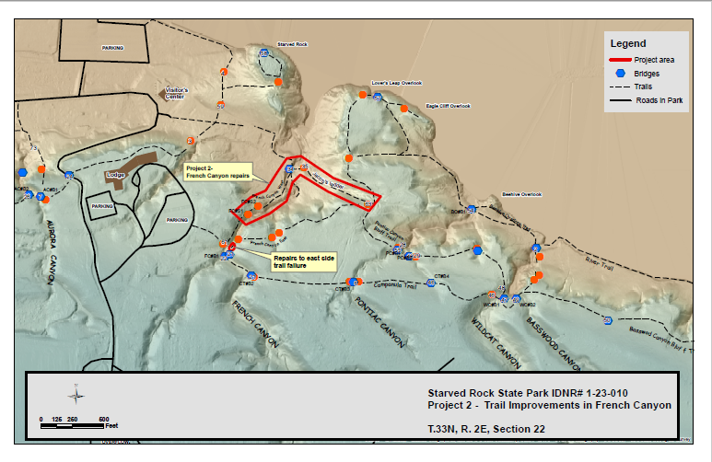

3: **Upgrades to the Water Filtration System**

This project will evaluate and rehabilitate 20-year-old Iron filtration system and provide new filter media and other needed repairs.

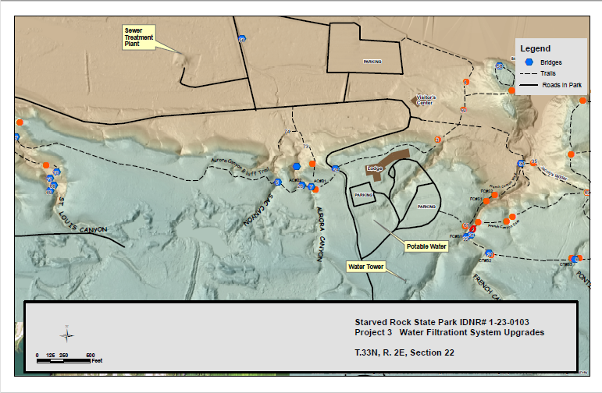

**4. Pontiac Canyon Bluff Trail**

This project will replace stairway 28 and bridge 55. IDNR will provide a set of 95% plans and specs already developed for this location. Specifications will need to be updated to meet current CDB standards.

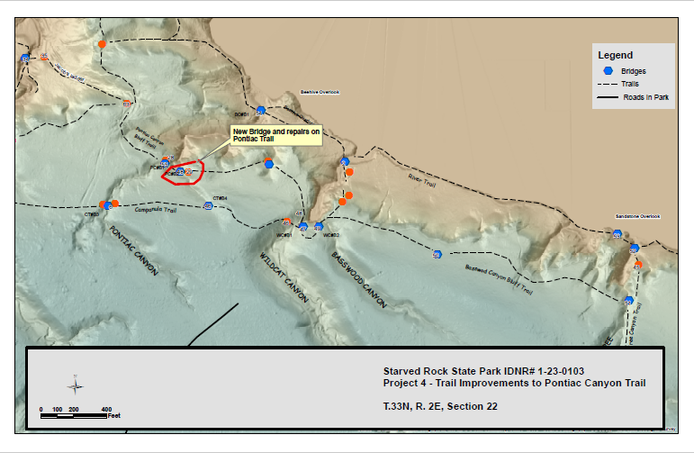

**5. Campground Electrical Upgrades to West Loop**

The electrical system for the 58 sites in the west loop should be upgraded to provide 50-amp, 30 amp and 20-amp service at each site, except for the campground Host Site which should be upgraded to a 100-amp service. The project will work with the local rural electric utility company, Cornbelt Electric, to install new transformers and primary electrical service lines as needed. New meters, base cabinets and distribution panels will be installed as needed. New distribution lines and RV service pedestals with 20, 30 and 50 amp receptacles will be installed at each site.

Other project work elements include grading and seeding all disturbed areas. All campsite markers and other signage will be replaced as necessary.

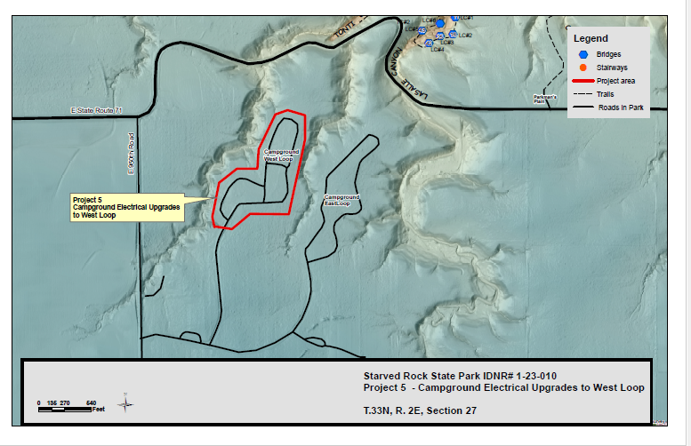

1. **Vault Toilets**

This project will provide four (4) standard IDNR concrete block vault toilets in the campground, and one (1) vault toilet in the at Parkman’s Plain Trailhead parking area. The project will include a survey and site design for each vault toilet location.

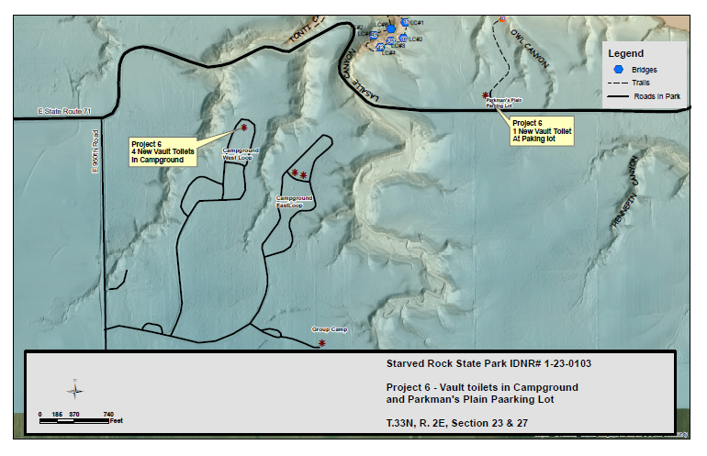

1. **Misc. Trail Repairs - River Trail Stabilization**

The consultant will survey the River Trail between Basswood Canyon and Owl Canyon (approximately 4,700 LF) and determine where the trail surface needs repairs or where additional riprap is needed to stabilize the trail during future flood events along the Illinois River.

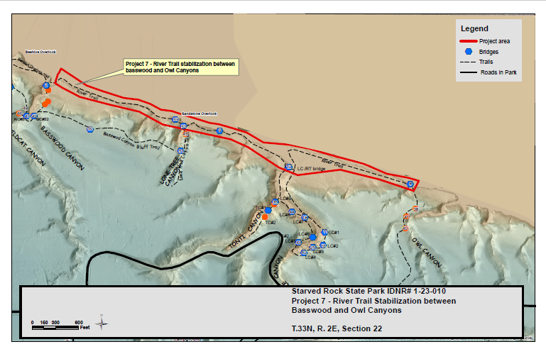

1. **Misc. Trail Repairs - Repairs to Stairway #45**

This project will make repairs to Stairway #45 in the section where the stairway treads are leaning to one side.

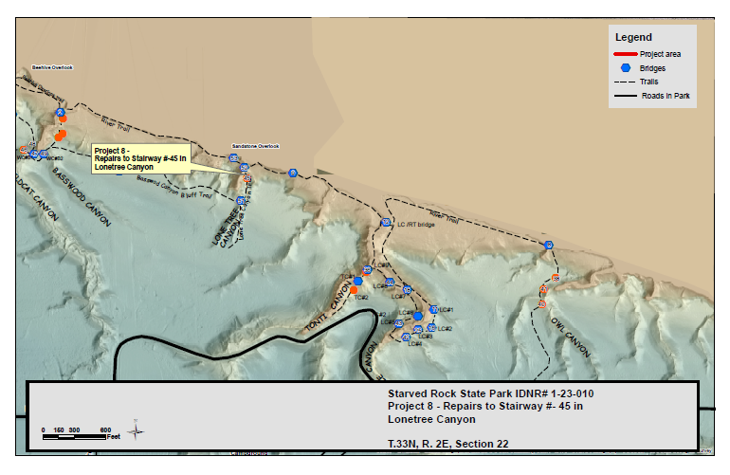

**9. Misc. Trail Repairs - Campanula Trail Walkway**

This project will add additional boardwalks to areas of Campanula Trail that are seasonally flooded between Bridge 46 and Stairway 46,

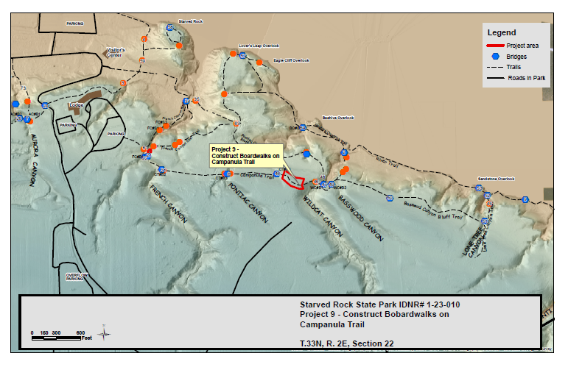

1. **Misc. Trail Repairs - New Deck on Bridge #24**

This project will replace the wood deck on bridge #24

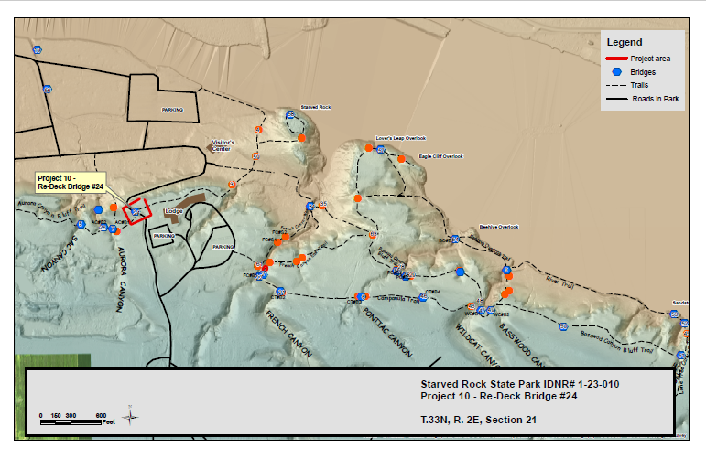

**IV. ADMINISTRATIVE COORDINATION.**

A. User Agency Contact.

The Project Manager shall be the point of contact for IDNR. All decisions required of the user agency shall be made via the Project Manager.

B. Site Visits

The A/E shall notify the Site Superintendent's office in advance of all site visits.

C. Correspondence.

1. The Project Manager, Regional Landscape Architect, Site Superintendent, and Division Manager shall be copied on all project correspondence, including e-mails, project meeting minutes, schedules etc.

2. The IDNR **File #1-23-010** shall be placed on each sheet of drawings, cover of project manual, and all correspondence.

**V. DOCUMENT DISTRIBUTION.**

Distribution of plans, specifications and/or other project documents for review by the user agency shall be sent to the following IDNR personnel throughout each stage of development. Those individuals not receiving review sets shall be notified when the drawings are transmitted for review.

**Project Manager: Michael Bauling, P.E., Region 1 Engineer 1 set**

Address: 1365 W. Castle Road

Oregon IL. 61061

Cell Phone: (815) 631-3765

Email: [michael.bauling@illinois.gov](mailto:michael.bauling@illinois.gov)

**Division Manager: Dale Brockamp, P.E. 1 set**

Address: Illinois Department of Natural Resources

One Natural Resources Way

Springfield, IL 62702-1271

Wk. Phone: (217) 785-4906 Cell Phone: (217) 414-2804

Email: [dale.brockamp@illinois.gov](mailto:dale.brockamp@illinois.gov)

**Site Superintendent: Alvin Harper 1 set**

Address: Starved Rock State Park

2678 E 875th Road

Oglesby, Il 61348

Wk. Phone: (815) 667-4726 Cell Phone: (815) 200-2007

Email: [Alvin.Harper@illinois.gov](mailto:Alvin.Harper@illinois.gov)

**Regional Landscape Architect: Louis Yockey 1 set**

Address: Illinois Department of Natural Resources

One Natural Resources Way

Springfield, IL 62702-1271

Wk. Phone: (217) 557-6724 Cell Phone: (217) 415-5585

Email: [louis.yockey@illinois.gov](mailto:louis.yockey@illinois.gov)

**Archaeologist: Dawn Cobb 2 sets**

Address: Illinois Department of Natural Resources

One Natural Resources Way

Springfield, IL 62702-1271

Phone: (217) 785-4992 Cell: (217) 836-8890

Email: [dawn.cobb@illinois.gov](mailto:dawn.cobb@illinois.gov)

**VI. SUBMITTALS.**

IDNR shall require the following items for the project file. All information shall be submitted to the Project Manager. All design data shall be submitted for review and approval prior to authorization. All construction related information shall be submitted either as obtained or at the completion of the project. **A failure to submit required design data prior to bidding shall result in IDNR rejecting the 100% plans.**

A. Unless otherwise noted or directed, submit all project-related information to IDNR in digital format including general correspondence, e-mails, photographs, studies/reports, drawings, construction documents, construction management records and record documents. Create an electronic project file to store all project information and documents.

B. Copies of all permits and environmental signoffs as obtained.

C. Survey notes and benchmark data that are established for the project shall be provided to IDNR on their "control data" forms (attached to the orientation package). See Section VIII for survey requirements.

D. Copies of all utility proposals, if required, prior to final design review and approval.

E. Construction quality control test results.

F. Soils investigation data, boring logs, and analyses.

G. Construction inspection reports shall be provided as per the A/E contract in the required format.

H. Approved shop drawings, samples and product data. The Project Manager shall be copied on all shop drawings for user agency review. All review comments will be submitted to the A/E within the prescribed review period. At substantial completion, deliver three (3) hard copies of all approved shop drawings, material data sheets and samples to IDNR. Unless otherwise noted or directed, all information to be created and filed in AutoCAD format.

I. Generate and document all design documents in AutoCAD software. It is required that the design drawings be developed using AutoCAD software.

All printed design drawings shall be no larger than "D" size (24" x 36". At the completion of the project the A/E shall provide three (3) sets of "record drawing" prints. All record drawings shall also be submitted to IDNR electronically in pdf format. The specifications shall be developed using electronic word processing. (DNR uses Microsoft Word.)

One set of "record drawing" documents and an electronic generated disk shall be transmitted under a cover letter to Dale Brockamp at the Springfield address noted above. The other two sets of prints and the other electronic generated disks shall be turned over to the regional engineer.

**VII. SPECIAL PROVISIONS.**

The following special provisions shall be considered in the design and execution of the project:

A. IDNR will undertake an internal analysis of this project for threatened and endangered species, cultural resources, and wetlands. This review is called a CERP for Comprehensive Environmental Review Process. A final internal analysis cannot be accomplished until exact project locations and access are determined.

**VIII. SURVEY REQUIREMENTS.**

A. The Department is developing a GIS database. IDNR is currently using AutoCAD 2020. Submittal of items in an earlier version is acceptable. Structures shall be located using the State Plane Coordinate system.

The following will also be required:

1. Digitized field control data compiled for map preparation must be done with software that is compatible with AutoCAD.

2. Projects utilizing electronic data collection must be done with systems that are compatible with AutoCAD. Horizontal and vertical control via the State Plane Coordinate System is required, regardless of whether electronic data collection is done. Materials shall be submitted on a CD disk which shall be appropriately labeled to indicate what is on the disk.

3. Unless otherwise required or directed, all survey data will utilize M.S.L.

B. One (1) Benchmark monument shall be provided

. All monuments shall be brass plates or iron rods imbedded into concrete to a stable depth at a minimum to prevent frost heave. **Do not place monuments on any tree.**

* Design of the monument shall be by the A/E and approved by IDNR. The A/E shall provide a post and a sign noting the presence of a survey monument at each benchmark. The A/E shall complete a IDNR benchmark form for each permanent benchmark set.
* The A/E shall provide a report of how the control is established i.e., traverse, GPS, levels, etc. The report shall also include closure error and a listing of the horizontal and vertical monuments utilized to establish the project control monuments.
* The A/E may, at their option choose to run in temporary control for the construction of the project and cast brass disks in the concrete slabs of structures for permanent control. At the completion of the project, the A/E shall then be responsible for running the horizontal and vertical control to these disks. If the A/E chooses to do this, the A/E shall also place the monument data on the record drawings, prior to submission.

**IX. BACK UP MATERIALS.**

**The following back up materials is provided for the A/E’s usage and is informational only. Availability of these materials, however, does not guarantee their degree of accuracy, nor their usefulness to the A/E for project development. The Department will provide the available building information and documents, appropriate for this project currently in DNR’s files, for A/E usage. If DNR provides typical details for usage on this project, the A/E is reminded that code changes and recent experience in the detail usage may require minor detail changes. The A/E shall be responsible for incorporating these changes in the design.**

A. Existing construction drawings and reports, provided at the orientation meeting.

B. Survey data and benchmarks, provided at the orientation meeting.

C. DNR benchmark data control form.

**“BENCHMARK FORM”**

SPACE RESERVED FOR RECORDING OFFICER

Land Survey Monuments Situated in

Section TWP

Range , P.M.

County, IL

|  |  |  |  |
| --- | --- | --- | --- |
|  |  |  |  |
|  |  |  |  |
|  |  |  |  |
|  |  |  |  |

RECOVERY TIE DRAWING

(SHOW MONUMENT DESCRIPTION, ACCESSORIES & KNOWN HISTORY AT EACH RECORD CORNER WITH TIES)

I, , HEREBY CERTIFY THAT THIS DOCUMENT WAS PREPARED UNDER MY DIRECTION IN ACCORDANCE WITH THE LAND SURVEY MONUMENT ACT CHAPTER 765 ILCS 220.

**IL Department of Natural Resources**

**Site / Project:**

**File #:**

**CDB#:**

(SEAL)

SHEET 1 OF ILL PLS NO. DATE

SHEET OF

“MONUMENT RECORD”

SECTION TWP

RANGE , P.M.

COUNTY, IL