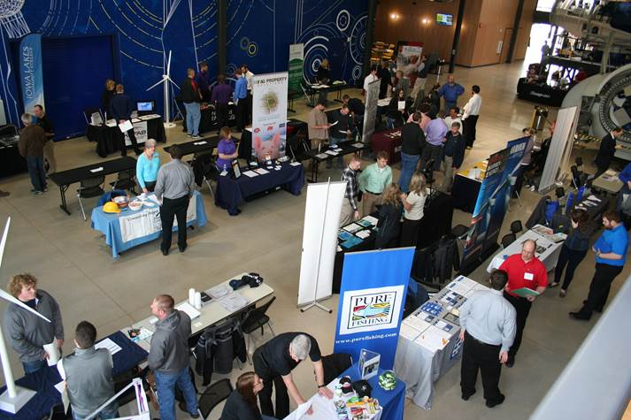
IOWA LAKES COMMUNITY COLLEGE
2019 FREE JOB FAIRs
Monday, March 4
Emmetsburg Campus Cafeteria & Commons

Tuesday, March 5
Estherville Campus Cafeteria &
Sustainable Energy Resources & Technologies Commons

OPEN TO THE PUBLIC
BUSINESS REGISTRATION INFORMATION NEEDED
Company Name(s): ____________________________________________________________
Contact Person(s): _____________________________________________________________
Contact Email(s): _______________________________________________________________________________
Contact Phone #: ______________________________________________________________
PLEASE MARK ALL LOCATIONS YOU WILL BE ATTENDING:
March 4, 1:00 until 2:30pm
____ Emmetsburg Campus Cafeteria 3200 College Drive, Emmetsburg, Iowa
Agriculture; Auto, Industrial & Marine Technology; Business; Construction; Early Childhood Education; Health Care; Hotel & Restaurant; Power Sports; Social & Family Services; Vet Tech; Welding; Arts & Science

March 5, 11:00 until 12:30pm
____ Estherville Campus Cafeteria 300 South 18th Street, Estherville, Iowa
Aviation; Business; Communications; Computer Programming; Criminal Justice; Digital, Social & Broadcast Production; Game Design & Development; Graphic Design; Social & Family Services; Web Design & Development; Arts & Science

March 5, 12:30 until 2:00pm
____ Sustainable Energy Resources & Technologies Facility 2421 7th Avenue South, Estherville, Iowa
Electrical; Engineering; Environmental; HVAC; Water Quality; and Wind Energy

Iowa Lakes will provide a 6’ table and 2 chairs, some locations will have access to electricity on a first come basis. For more information or to register contact Melissa Lutat at mlutat@iowalakes.edu or 712-362-7926.

