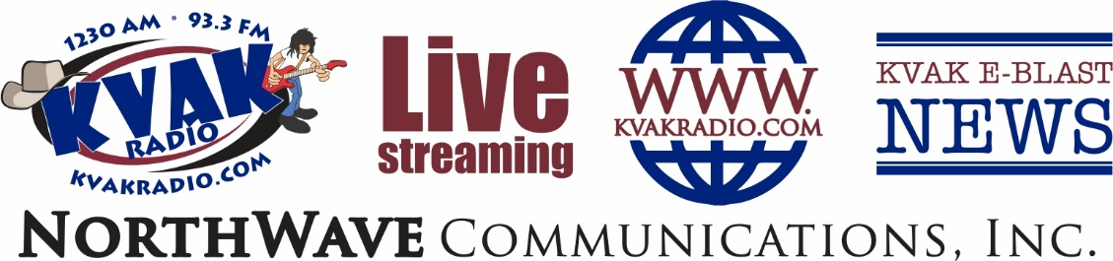
KVAK’s Buccaneer broadcast
8-Month on-air & digital program


Sports & Activity Features in KVAK’s E-Blast Newspaper Every - MONDAY
Weekend Event Updates & Wrap-Ups On-Air Every - TUESDAY
Interviews On-Air Every - THURSDAY
Upcoming Events & Game Times On-Air Every - FRIDAY

MVP: Sponsor ALL 3 On-Air & Digital Features - Bonus Mentions
Sponsor recognition in every Tuesday Wrap-Up, Friday Upcoming Events Listing and Thursday On-Air Interviews with athletes, coaches, and students. Prominent recognition on-air, in KVAK’s E-Blast Newspaper, and on KVAK’s website. Bonus mentions in Promotional Radio & Digital Content
One-Time Payment of $995 ($124.38/Mo) – Program Runs 6x Each Day

Sports Fan: Sponsor 2 On-Air & Digital Features
Sponsor recognition in every Tuesday Wrap-Up and Friday Upcoming Events Listing. Mentions in KVAK’s E-Blast Newspaper and KVAK’s website. Bonus Mentions in Promotional Radio Content

One-Time Payment of $695 ($86.88/Mo) - Program Runs 6x Each Day

Cheerleader: Sponsor 1 On-Air & Digital Feature
Sponsor recognition in every Friday Upcoming Events Listing.
Recognition on-air and in KVAK’s E-Blast Newspaper and on KVAK’s website
One-Time Payment of $395 ($49.38/Mo) Program Runs 6x Each Day

Business Name: Phone: Fax:

E-Mail: Signature:

YES – I would like to be an MVP Sponsor – Cost $995
YES – I would like to be a Sports Fan Sponsor – Cost $695

YES – I would like to be a Cheerleader Sponsor – Cost $395

KVAK’s Special Offer: Pair your Sponsorship with a 12/Mo Community Engagement Schedule
Receive KVAK’s “Premier Client Rate” and get a 36-Spot Plan for cost of a 30-Spot Plan!

Interested in a custom schedule or campaign? Contact KVAK! 

