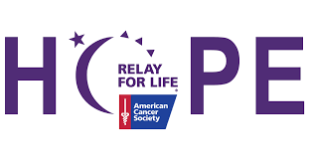
Relay For Life Des Moines Co Running For A Cure
9am April 1, 2023
Crapo Park Overlook
Burlington IA 52601

Entry Fee: Pre-register by March 10, 2023 -$25, $30 after till race day. T-shirts guaranteed for Pre-registered participants only. Complete your t-shirt size below if you wish to order one. Groups of 10 or more can receive a $5 discount for each registered participant.
Onsite registration begins at 8 am OR you may register by mail
Information: for additional information, please contact Mindy Gerling at mndmariem@gmail.com

------------PLEASE PRINT ALL INFORMATION-ONE ENTRY PER FORM--------
Mail Registration form to Des Moines Co Relay c/o Mindy Gerling, PO Box 3, West Burlington IA 52655
Make checks Payable to: Relay for Life Des Moines Co
Name:____________________________________________
Address:__________________________________________ City:________________________
State:_____________ Zip:_______________ Phone:____________________________
Email:____________________________________________
Shirt Size (Circle one): YM YL S M L XL 2XL 3XL Amount enclosed:________________
Waiver: In consideration of acceptance of this entry, I waive any and all claims for myself and my heirs against Relay for Life of Des Moines co and The American Cancer Society employees, volunteers, sponsors for injury or illness which directly or indirectly results from my participation in this event. I further state I am in the proper physical condition to participate in an event of this nature.

Signature:________________________________________Date:________________
(Parent Signature if under 18)

