**NOTICE OF AGENDA**

Notice is hereby given that the City Council of the City of Wellington will hold a regular City Council Meeting on Wednesday, February 13, 2019 at the Wellington City Hall, located at 150 West Main Street, Wellington, Utah. Meeting shall begin promptly at 5:00 pm and the agenda shall be as follows:

1. Work Session
   1. Voucher & Warrants
   2. Planning and Zoning Updates
   3. Department Reports
      1. Public Works Department
   4. Discussion of Adopting a Residential Anti-Displacement and Relocation Assistance Plan
   5. Review of Wellington City Policy and Procedures Regarding Payment of Utility Accounts, Disconnections, and Reconnection Procedures
   6. Council Reports
2. Adjourn

Posted this 12th day of February, 2019

_-s Glenna Nelson___________

City Recorder

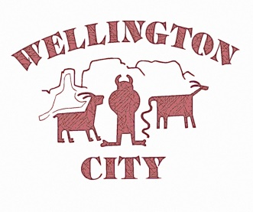

In compliance with the Americans with Disabilities Act, persons needing auxiliary services for this meeting should call Glenna 435-637-5213 at least 24 hours prior to the meeting. A copy of this notice was emailed to the ETVNews, a newspaper of general circulation within Carbon County, and to Radio Station KOAL/KARB.