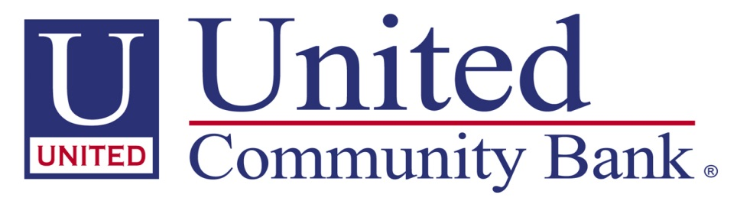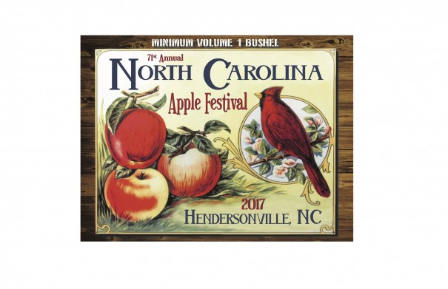
2018 Apple Farmer of the Year Award
NOMINEE __________________________________________________________________
FARM/ORCHARD___________________________________________________________
ADDRESS __________________________________________________________________
PHONE NUMBER __________________________________________________________
NAME OF PERSON NOMINATING _________________________________________
PHONE NUMBER OF PERSON NOMINATING _______ - _______ - ___________
WHAT MAKES THIS APPLE FARM/FARMER SPECIAL? ______________________________________________________________________________________________________________________________________________________________________________________________________________________________________________________________________________
______________________________________________________________________________________________________________________________________________________________________________________________________________________________________________________________________________
______________________________________________________________________________________________________________________________________________________________________________________________________________________________________________________________________________

PLEASE SUBMIT YOUR APPLICATION NO LATER THAN AUGUST 3, 2018 BY MAIL TO UNITED COMMUNITY BANK 2520 CHIMNEY ROCK ROAD, HENDERSONVILLE, NC 28792 BY FAX 828-698-5686, OR EMAIL fair_waggoner@ucbi.com or karen_yockey@ucbi.com

