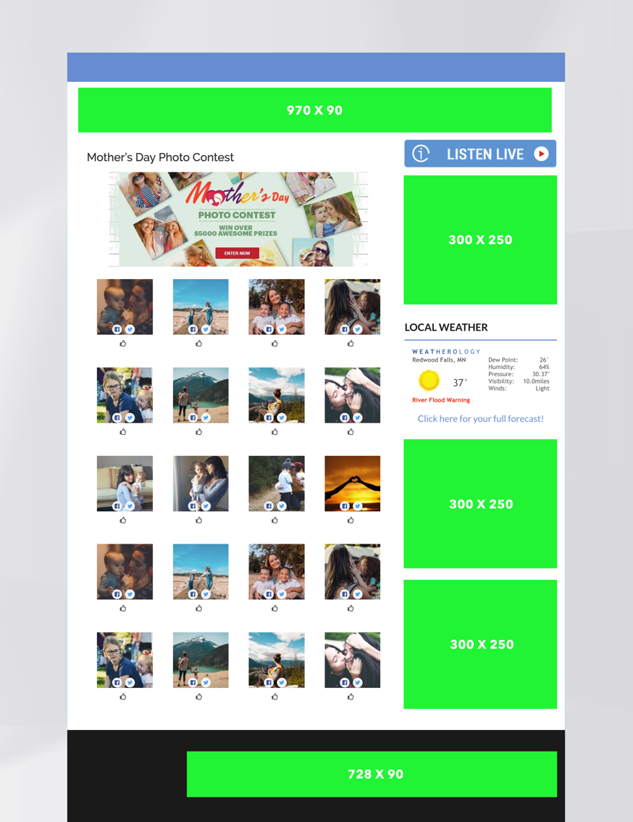

Website Promotion

* 970x90  Leaderboard $___
* 782x90  Leaderboard $___
* (3) 300x250 $_____

On Air-Promotion

* X Spots and mentions

Social & VIP Database Promotion

* (5) Social Media posts for Promotion with your brand named as Sponsor
* X VIP emails, text messages, and push notifications with your sponsorship

Leads

* A full list of entrants with email, phone numbers, and birthdays for post-promotion marketing

As a Sponsor, you will receive:

**GET EXPOSURE! Your brand will be featured on the program’s Submission and Voting pages on the website and promoted via social media posts!**

**Get LEADS! We supply you with a list every entrant to the contest to re-market.**

**Get in on the Mother’s Day and Father’s Day Photo Contest!**