Lenawee Broadcasting Company
242 W. Maumee Street/PO Box 687
Adrian, MI 49221
Phone: (517) 263-1039 Fax: (517) 265-5362
juliek@wlen.com

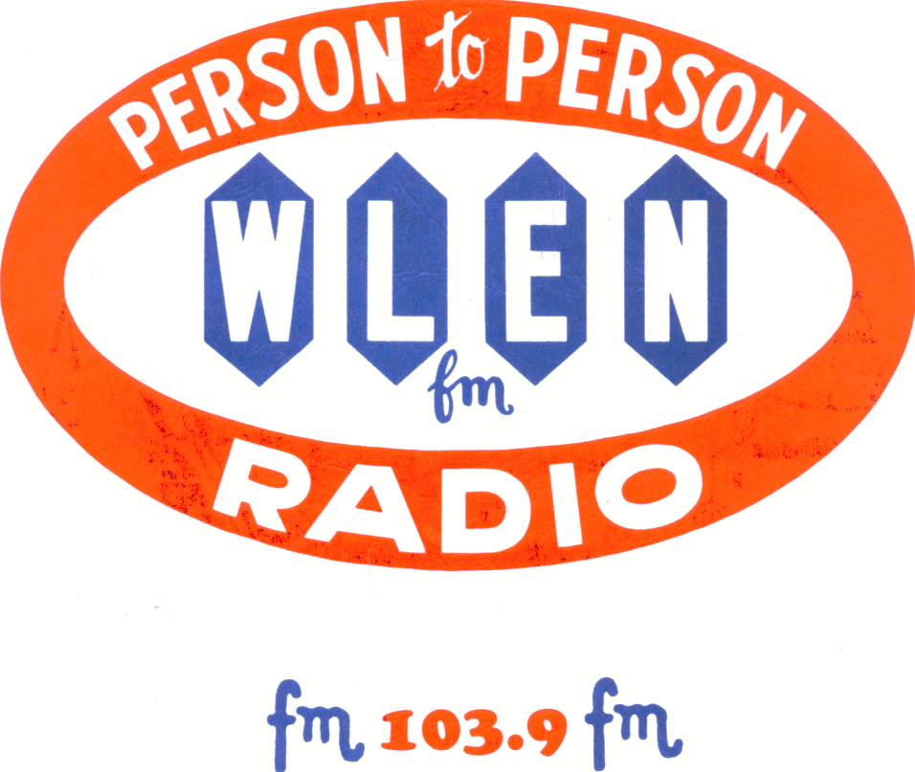

To: Community Group

From: Julie Koehn-WLEN/Lenawee Broadcasting Company

Re: Community Service Program

Applications are now being accepted for the 2026 “Hometown Hope” broadcasting grants. These grants are awarded monthly to community groups in the Lenawee County area. Community groups, civic organizations, non-profits, and school or church-based groups are encouraged to apply. The grant recipients will receive a month-long advertising campaign with 103.9 WLEN valued at more than $5600.00.

The grant package will include (150) :60 announcements, a community conversation with Dale Gaertner, a 7:40am interview on the Morning Show, and a click-thru banner ad on our website or a 2-hour live broadcast during the month of your selection (which must be scheduled Mon-Fri 9am-5pm). It also includes a 1-2 minute video, created by our video department which will be shared in our social media and is yours to use. In addition, you will be featured on our sister station in a Q-Cares segment…a 3 minute interview in our morning show with Shannon Renee.

“Hometown Hope” will serve to inform the public of projects your organization is undertaking, as well as be used to recruit new members or promote fundraising opportunities. In short, WLEN wants to enlighten the community with the “hope” your organizations bring to our community every day.

If your organization is interested in being featured during one of the months in 2026, fill out the attached request. Our selection team will review these requests and will contact you if you are selected. To be considered for this program, please return this request by November 30, 2025, to PO Box 687, Adrian, MI 49221, or email to juliek@wlen.com .

If you have any questions, please direct them to Julie Koehn or Kathy Williams at (517) 263-1039 or juliek@wlen.com kathywlen2011@gmail.com

2026 103.9 WLEN Hometown Hope

McDonald’s of Adrian and Hudson and Acrisure
Request Form
Attach additional sheets, to tell your story
Mail To: P.O. Box 687
Adrian, Michigan 49221
Or email: juliek@wlen.com
(517) 263-1039 • (517) 265-5362-fax
Deadline: 11/30/25

Community Organization: ________________________________________________________

Director Name: ________________________________________________________________

Contact Name, best phone number, and E-mail:

________________________________________________________________________

Address:
________________________________________________________________________

Background of organization in Lenawee County:

Number of people who are served by your organization:

Something people in the county don’t know about your group:

What would you like to accomplish by having a month on the program?

Which month of the year would you like to be on “Hometown Hope”?

