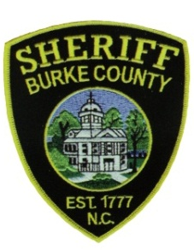
BURKE COUNTY SHERIFF’S OFFICE
Sheriff Steve Whisenant
CRIMINAL INVESTIGATIONS / NARCOTICS DIVISION
PRESS RELEASE

The two people found dead off Interstate I-40 Exit 119 on September 6, 2022, have been identified. The male was Daniel Allan Nolan, Jr., age 45 from Ohio. The female was identified as Jocelyn Danielle Hall from Ohio, age 39. The two individuals were believed to be homeless, and the investigation did not reveal any signs of foul play.

Agencies Involved:
Burke County Sheriff’s Office
Burke County EMS
NC State Highway Patrol

